Wednesday 6th January 2021

OLI (Our Learning Intention): to design a food inspired Epiphany plate.

Today is the Epiphany Holiday.
The holiday celebrates three different things;
- The three kings visiting baby Jesus when he was born,
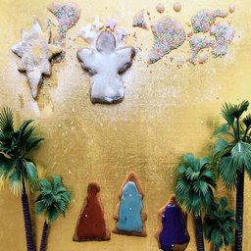
- Jesus later being baptised by John the Baptist,
- Jesus’ first miracle; turning water into wine.

RE this week is to design a scene using food to create one of the events we celebrate during the holiday of Epiphany.
Inspiration below! Please show me a photo of their work on Class Dojo!
