English/History task-
Today is Remembrance Day. I would like you to write your own Remembrance poem. Remember poems do not have to rhyme! Here are some examples below, including the famous poem ‘In Flanders Fields.
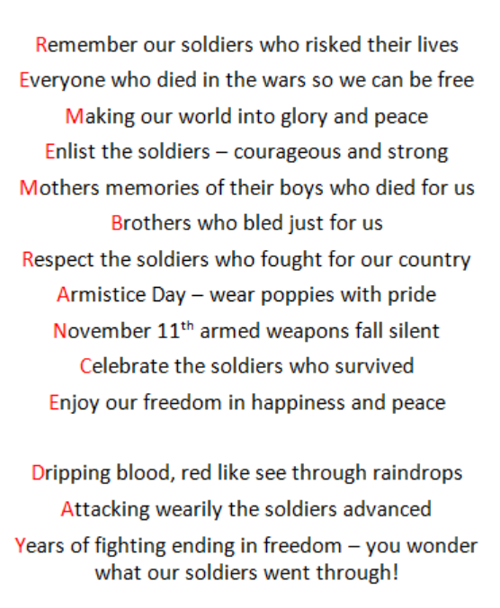
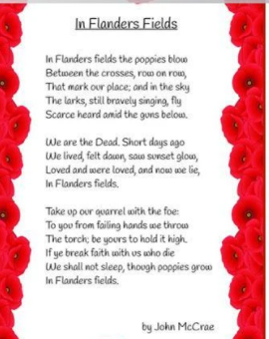
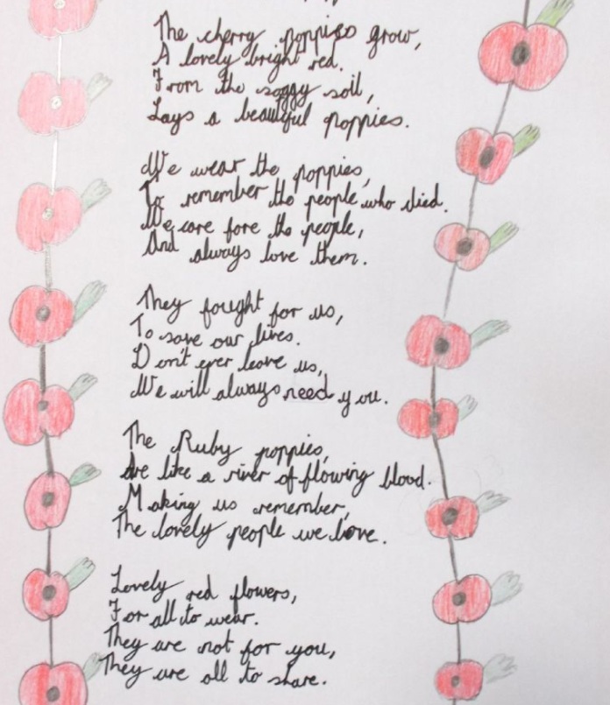
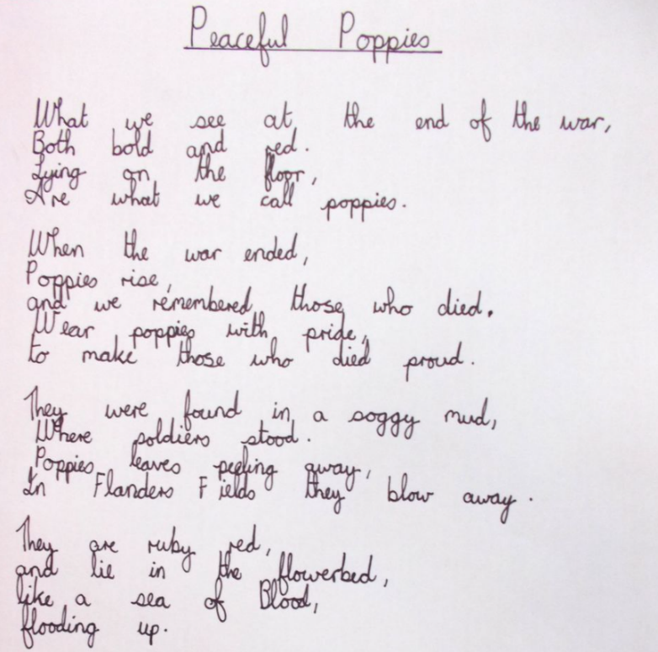
Remember to include verses and figurative language (e.g personification, similes, metaphors etc).
You can also do some art work to accompany your poem! Have a look at the Powerpoint of art ideas.

