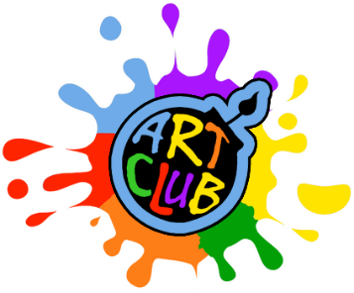

Art Club
Dear parents,

During the three weeks and three days up to the half term, I will be running several Art Clubs for pupils.
On this occasion the clubs will be per year group from 3.30 – 4.45pm at a cost of £5 per session.
They will take place in the Nursery classroom. Pick up will be from outside the Nursey gate.
They will run as follows:

Year 2 – Monday 8th March to Monday 29th March (4 sessions)
Year 4 - Wednesday 10th March to 31st March (4 sessions)
Year 3 – Thursday 11th March to 25th March (3 sessions)

If your child wishes to take part in the Art Club for their year please return this form by Thursday 4th March to admin@olsj.hackney.sch.uk

Kind regards,

Miss Fiona
________________________________________________________

I would like my child

…………………………… in Yr 2 to come to Art Club on Monday.

…………………………… in Yr 4 to come to Art Club Wednesday.

…………………………… in Yr 3 to come to Art Club Thursday.

