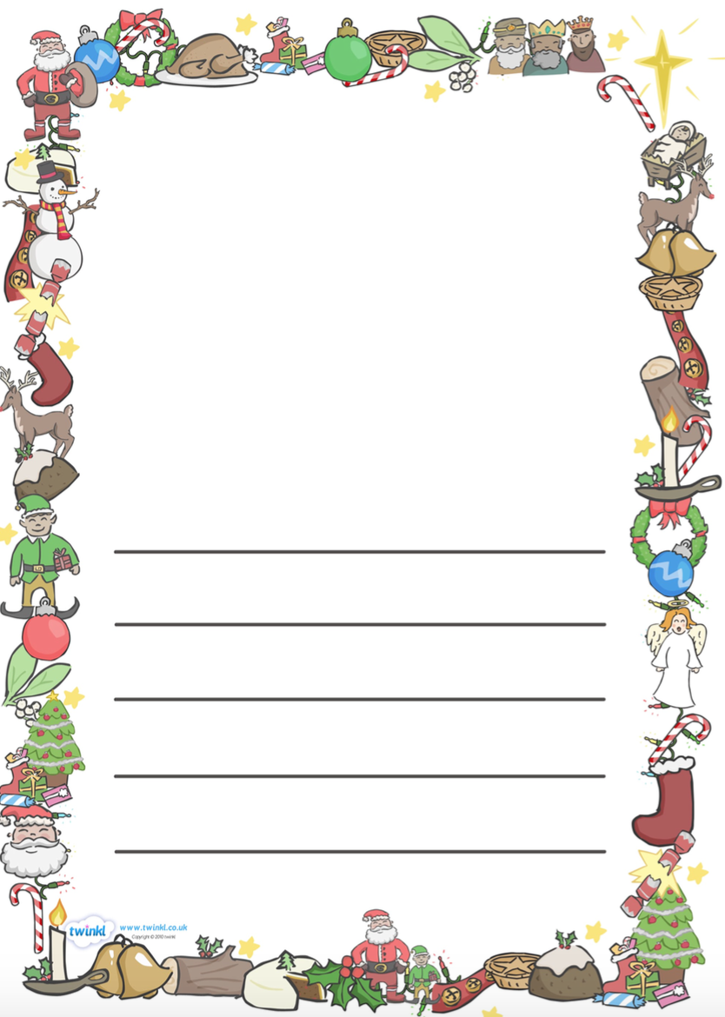

________________________________________________________________________________________________________________________________________________________________________________________________________________________________________________________________________________________________________________________________________________________________________________________________________________________________________________________________________________________________________

|  |
| --- |
| **Steps To Success:** |
| - I can say my sentence out loud before writing it. |
| - I can re-read my sentence to check it makes sense. |
| - I can use my phonics knowledge to help me sound out words. |
| - **ABC** (capital letters) and (full stops). |
| - Finger spaces |

I know this Christmas may have been quite different but can you think of the best bit of your Christmas?

Wednesday 6th January 2021 **OLI: to describe your Christmas.**