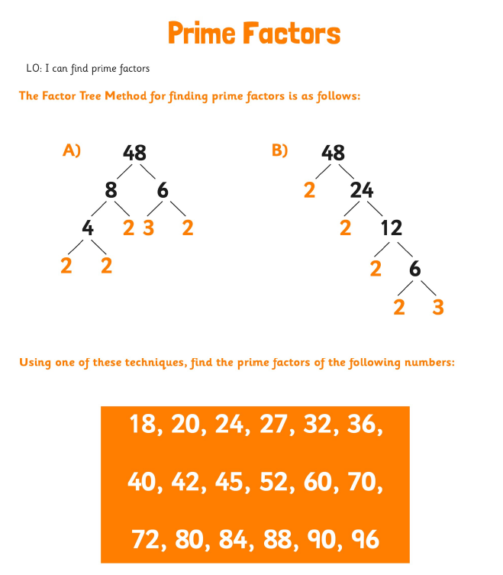

Extension: Write your answers in index form. E.g 48 written as the product of its prime factors would be 48= 2⁴ x 3.

