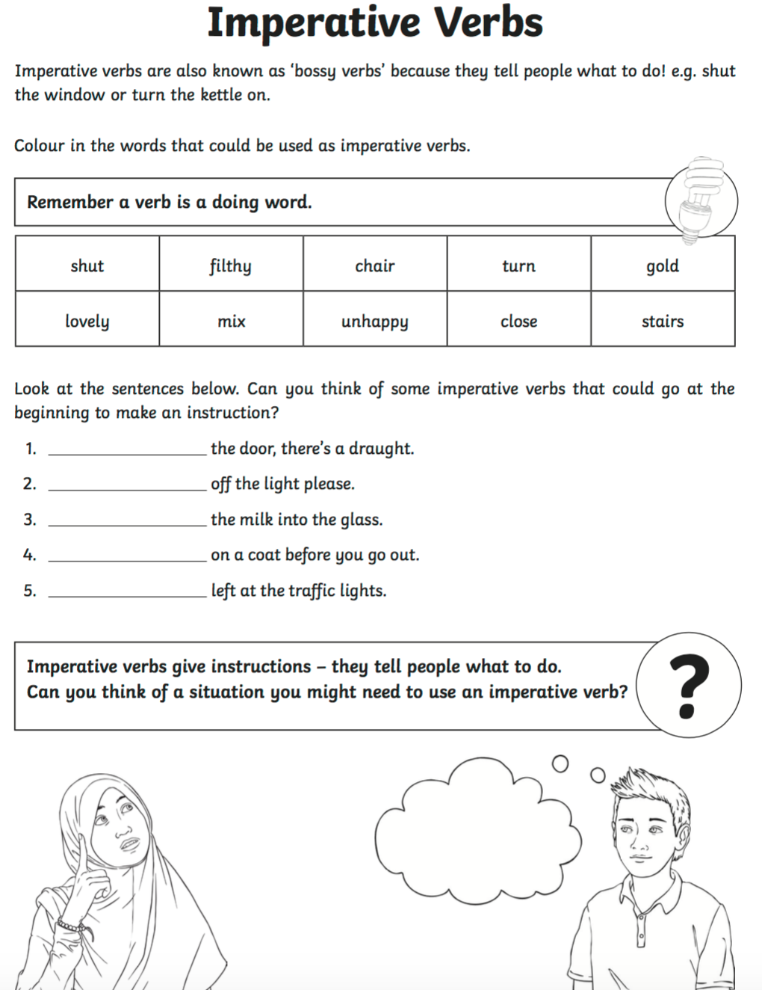

Week commencing Monday 11th January 2021

**OLI: to write instructions using bossy verbs.**

**Extension: Write some of your Simon Says instructions, underlining the bossy verb.**

_________________________________________________________________________________________________________________________________________________________________________________________________________________________________

**Colour in the bossy verbs! You can read the words to your child to help them.**

**Look at the sentences below. Can you think of some bossy verbs that could go at the beginning to make an instruction? Read the sentences to your child first to help them.**

**Bossy verbs give instructions- they tell people what to do. Can you play Simon Says with your family giving instructions? Each time you give an instruction, you will use a bossy verb. Think about what word in the instruction is the bossy verb.**