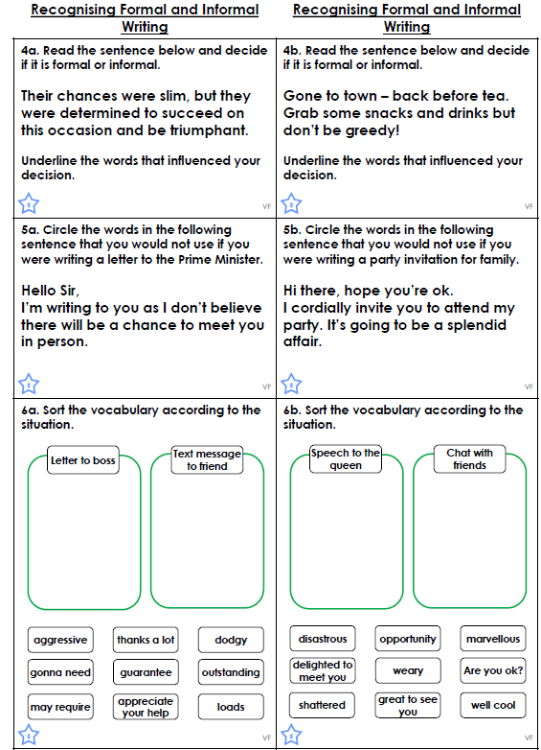
Choose to complete one of the worksheets below. We will discuss the answers in this afternoon’s session!

