12/01/21 – 22/01/21
Science project – Earth and Space

Please continue your Science project this week.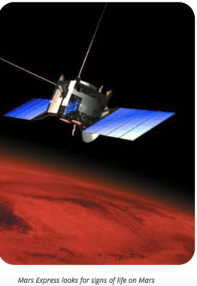

We will be sharing work on Thursday’s Google meet.

Suggested subject for each chapter:

- What is the solar system?
- What are the rocky planets?
- What are the gas planets?
- What is the Sun?
- How do reactions power rockets?
- How do you stay alive in space?
- Do waves hold the secret of space?
- Can you make outer space in your kitchen?
- How do astronauts get home?
- All about Tim Peak.
You can always add more topics you’d like to write about. (Life on Mars?)

Please follow BBC Bitesize videos and include drawings.

https://www.bbc.co.uk/bitesize/topics/zkbbkqt

Enjoy your project!

