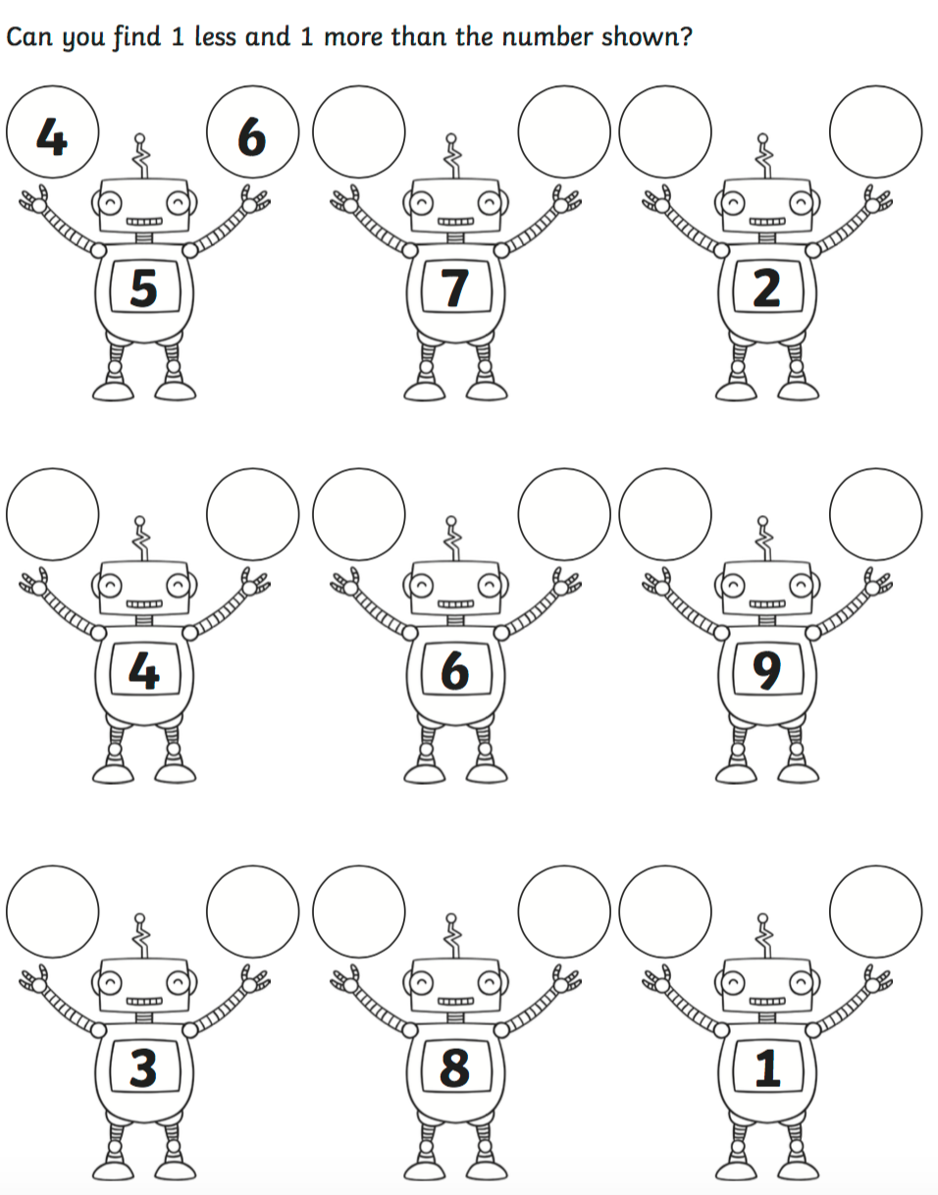
OLI: To find 1 more and 1 less to 10.
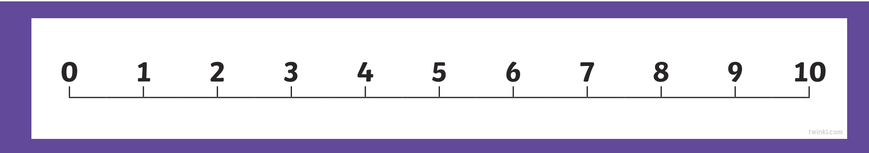
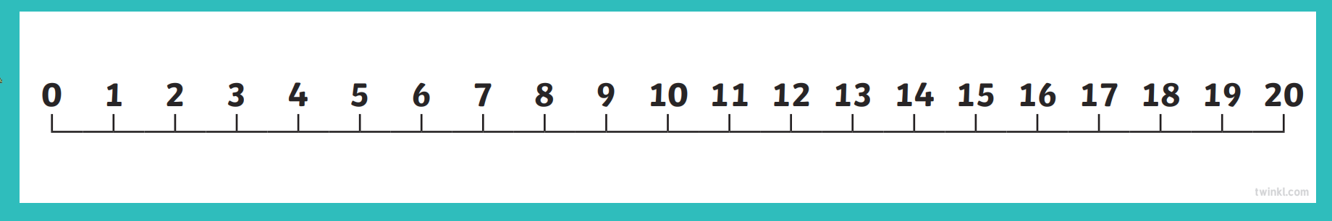
OLI: To find 1 more and 1 less to 20.
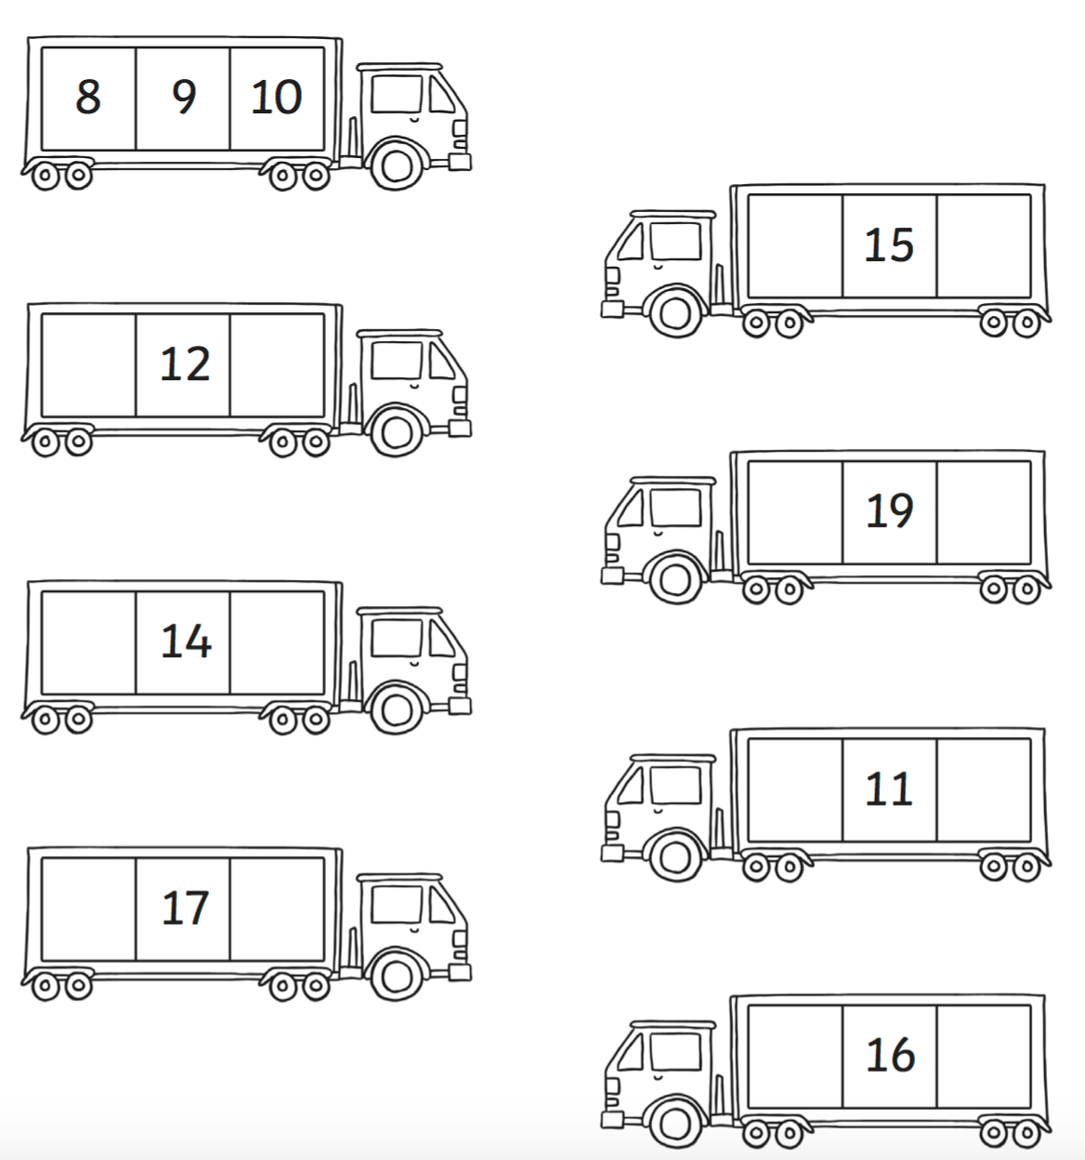

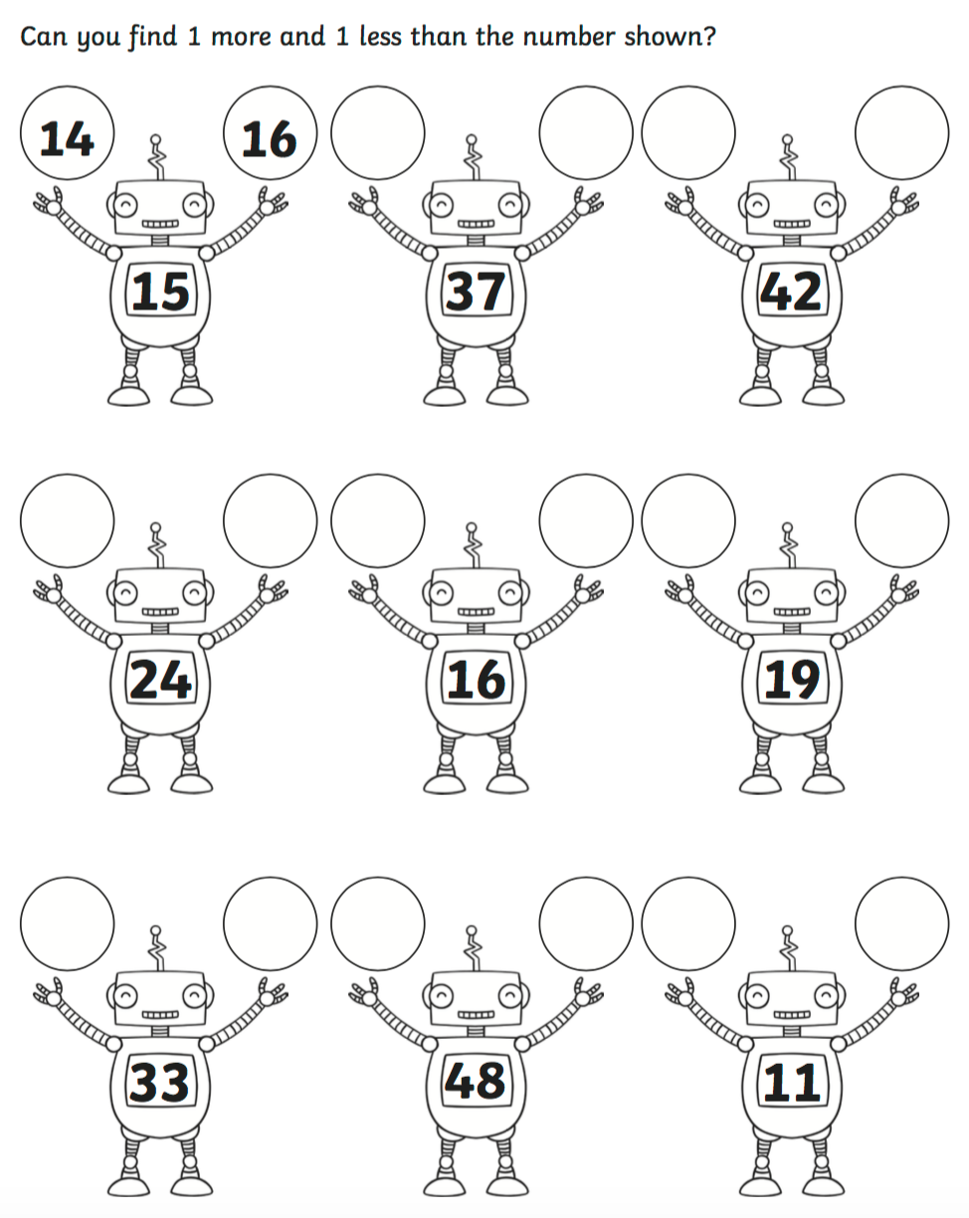
OLI: To find 1 more and 1 less.

