Our Lady & St Joseph Catholic Primary School Governing Body
The school is governed by a body of 12 governors, some of whom are elected, and others appointed. The Governing Body has a significant role in maintaining the Catholic ethos of the school, in making strategic decisions, particularly on finance, and in holding the school to account through its challenge to the Headteacher. The governing body of Our Lady & St Joseph Catholic Primary School usually meets three times a year. Its members at 24 June 2026 are:

Governors  Governor name |  |  | Date of current appointment | Date of  expiry | Category/  Appointed by | Term of office in years* | Entry in register of business interests 2023-24 | Attendance 2023-24  (School Year)
1 | Vacancy |  |  |  | Foundation/ Dioc | 4 | Nil
2 | Michelle | Hogan-Tricks | TBC | TBC | Foundation (prev PG from 1/9/2019) | 4 | Nil | 2/3
3 | David | Blackwell | TBC | TBC | Foundation/ Dioc | 4 | Nil | 3/3
4 | Yvonne | Coley | 01/04/2022 | 31/08/2025 | Foundation/ Dioc | 4 |  | 2/3
5 | Vacancy
6 | Eleanor | Taylor | 01/04/2022 | 31/08/2025 | Foundation/ Dioc | 4 |  | 2/3
7 | Mari-Anne | Chiromo  Chair** | 01/09/2022 | 31/08/2026 | Foundation/ Dioc | 4 | Nil | 3/3
8 | Ignacio Fernandez | Dussaut  V/ Chair** | 01/04/2024 | 31/03/2028 | Parent/ elected | 4 | Spouse isTrustee and Secretary of OLSJ Parents’ Association which donates money to the school. | 1/1
9 | Sophie | Stafford | 20/10/2025 | 19/10/2029 | Parent/ elected | 4
10 | Vacancy |  |  |  | LA/ governing body | 4
11 | Aoife | O’Grady | Ex officio | Ex officio | Headteacher | Ex officio | Nil | 3/3
12 | Nick | James | 01/01/2024 | 31/12/2028 | staff/ elected | 4 | Nil | 2/2
 | Julius | Monero | 02/11/2022 | 25/02/2029 | Associate/ governing body | 1 | (Married to Serina Monero, former governor) | 2/3
 | Bertlyn | Springer | 02/11/2022 | 25/02/2029 | Associate/ governing body | 1 | Self employed close protection officer. Volunteer playworker | 1/3
 | Enda | Larkin | 24/06/2026 | 23/06/2027 | Associate/ governing body | 1 | Nil | N/A
*Foundation governors: 3 to 4 years depending on date of appointment
** Elected for a two year term 22 Oct 2025 – expires in Autumn 2027

Former governors
The following were governors or associate members previously but are no longer governors or associate members:
Governor name | Date of appointment | Date of  Leaving | Reason for leaving | Category/  Appointed by
Serina Monero | 01/09/2022 | 29/04/2025 | Resigned | Parent/ elected
Derek Hyett | 01/10/2019 | 31/08/2023 | Term expired | Foundation/ Dioc
Joycelyn Marshall | 01/04/2022 | 31/08/2025 | Term expired | Foundation/ Dioc
Shaqira Bembridge | 26/02/2025 | 25/02/2026 | Term expired | Associate / GB

Committees and working groups:
The governing body has the following committees (*which meet termly):
Curriculum & Standards Committee* | Resources Committee* | Headteacher Performance Review | Admissions, Staff, Performance Review and Pupil Panels (Meeting as necessary)
Michelle Hogan-Tricks – Chair | David Blackwell – Chair | Mari-Ann Chiromo | Membership to be drawn from eligible governors
Mari-Anne Chiromo | Ellie Taylor | David Blackwell | Membership to be drawn from eligible governors
Aoife O’Grady – Head | Enda Larkin |  | Membership to be drawn from eligible governors
Ignacio Fernandez Dussaut | Mari-Ann Chiromo | Advised by LL – External adviser | Membership to be drawn from eligible governors
Nick James | Aoife O’Grady – Head |  | Membership to be drawn from eligible governors
Sarah Woodhouse – Guest | Ignacio Fernandez Dussaut |  | Membership to be drawn from eligible governors
Sophie Stafford | Julius Monero |  | Membership to be drawn from eligible governors
 | Nicola Cavanna – Adviser

The instrument of government Meeting dates 2025-26
Resources | Curriculum & Standards | Governing Body
Weds 12 Nov 2025 3.30pm  ONLINE | Weds 22 Oct 2024 3.30pm  AT SCHOOL | Weds 22 Oct 2025 4.30pm  AT SCHOOL
Weds 25 Feb 2026 3.30pm  AT SCHOOL | Weds 18 Mar 2026 4.30pm  ONLINE | Weds 25 Feb 2026 4.30pm  AT SCHOOL
Thurs 21 May 2026 3.30pm  AT SCHOOL | Weds 3 June 2026 4.30pm  ONLINE | Thurs 21 May 2026 4.30pm  AT SCHOOL

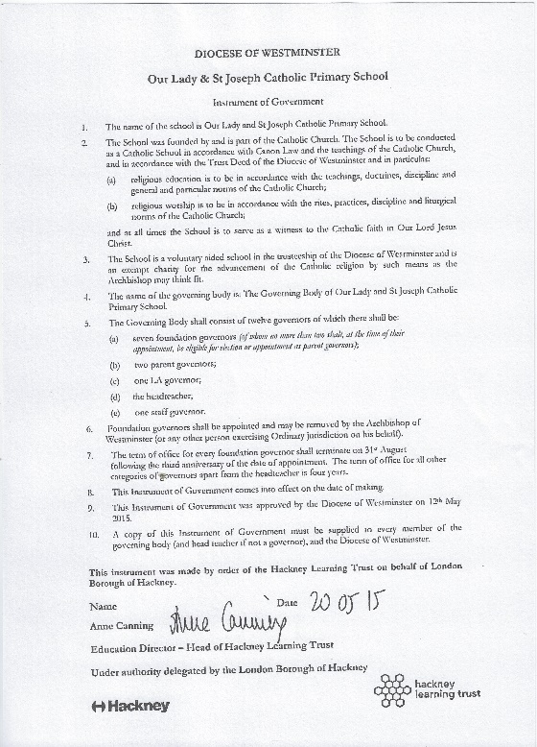
Link governors
MHT | SEND
DB | RE
MAC | Safeguarding
DB | Single Central Record
IFD | Assessment

