28th August 2025
Dear Parents/Carers,
We would like to let you know about a small change to the cost of our Breakfast Club.
From 3rd September 2025, the charge will be:
- Previous price: £3.50 per session
- New price: £4.00 per session
We have worked hard to keep costs as low as possible, but with rising expenses we need to make this small increase so we can continue offering the same quality care, food and activities that the children enjoy each morning.
A reminder that:
- Bookings are not necessary – children can come along on the day if that’s easiest for you.
- If you prefer, places can be booked in advance through the School Money app.
- The earliest drop-off time is 7:45am, and the latest arrival time is 8:20am.
Thank you so much for your continued support – Breakfast Club is a lovely way for children to start their day, and we really value being able to provide this service for our families.
If you have any questions, please contact the school office on 020 7254 7353 or admin@olsj.hackney.sch.uk.
Warm regards,
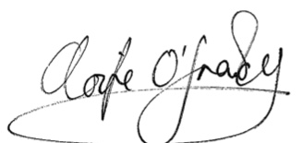
Aoife O’Grady
Headteacher

Yours sincerely,

Aoife O’Grady
Headteacher

