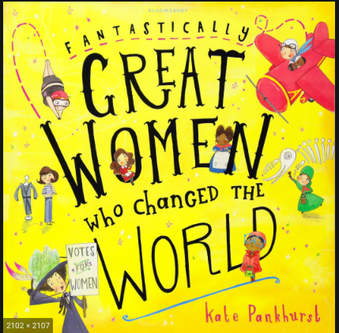

International Women’s Day.

We are celebrating International Women’s Day on 8th March with a quiz about some fantastic women who changed the world.

Research and write about Jane Austen, Coco Chanel, Frida Kahlo, Mary Seacole and Anne Frank in order to prepare and secure the best chances for your team!

Also, you can research a woman of your own choice.

You should write a paragraph about each of these women.

Have fun!

