R.E- Friday 22nd January
Your task for today is to design a new cover for a children’s Bible. You can focus on a particular story to draw e.g Noah’s ark or you can use a collection of different images to make your cover.
Remember it has to be appealing to children so think about the picture and colours you will use carefully! You can either do this by computer and submit on Google Classroom or by hand and send me a photo!

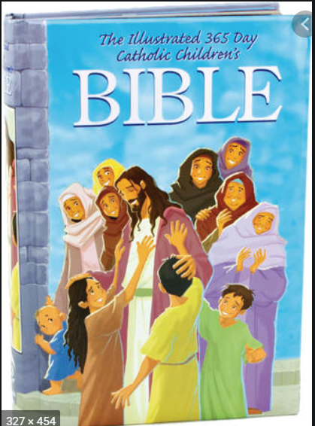
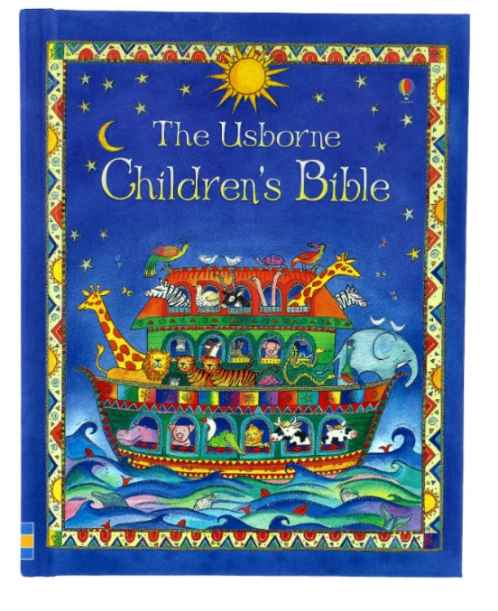
Here are some examples that might inspire you!

