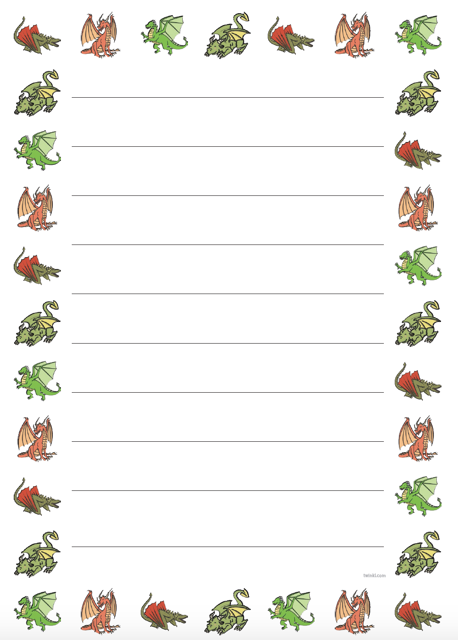

Thursday 14th January 2021

**OLI: to give instructions to a dragon.**

Draw a dragon then play ‘Simon Says’ with it. Make sure each instruction includes a bossy verb! Underline the bossy verb.

_________________________________________________________________________________________________________________________________________________________________________________________________________________________________________________________________________________________________________________________________________________________________________________________________________________________________________________________________________________________________________________________________________________________________________________________________________________________________________________________________________________________________________________________________________________________________________________________________________________________________________