Living Thing | Habitat | Adaptive traits (list 2 or more)
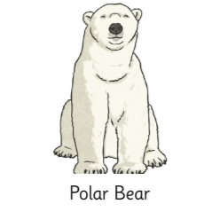 | 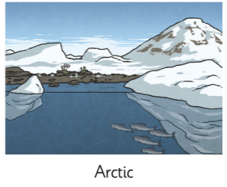 | - Its white fur enables it to camouflage in the snow  - Its nostrils can close up so water does not enter when swimming.
Complete the worksheet below, I have done the first one as an example for you. You can find pictures and copy them from the computer or you can draw your own!
If you are stuck on what animals to choose, here are some suggestions: dolphin, camel, hedgehog, toucan. Or even a cactus or coral!

