Art project- to sketch an animal that is native to Australia. Here are some ideas below!
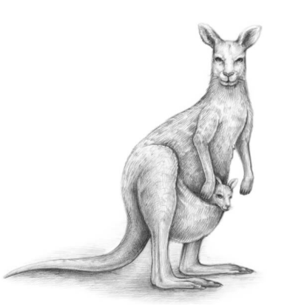

How to sketch a kangaroo: https://www.youtube.com/watch?v=m1AmcEWXxp8.
There are many other links too!

How to draw a koala:
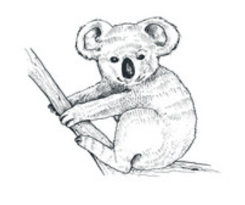
https://www.youtube.com/watch?v=CYIpFE1nKOE

