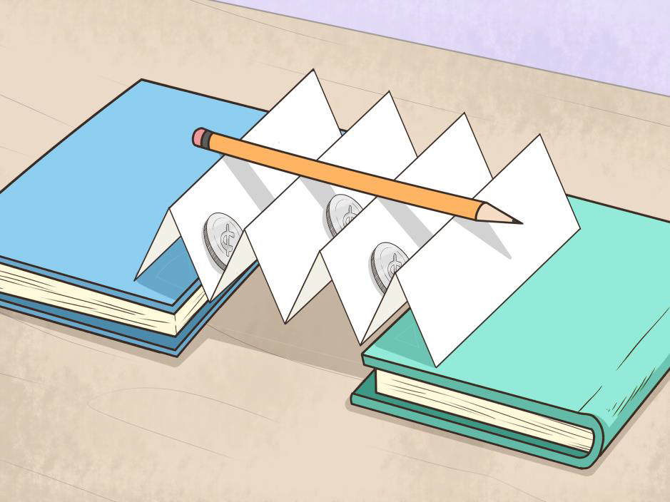

Things I need:

* Plain paper
* Boxes or books to create a ‘gap’ to put your bridge across
* Scissors
* Glue
* Coins (1p’s if possible)
* An apple

This is a photo of my paper bridge:

Items I can put on it without it falling down:

____________________________________________________________________________________________________________________________________________________________________________________

Week commencing Monday 18th January 2021

**OLI: to make a paper bridge.**