Aviation House  125 Kingsway  London  WC2B 6SE | T 0300 123 1231  F 020 7421 6855  enquiries@ofsted.gov.uk  www.ofsted.gov.uk |  |  | 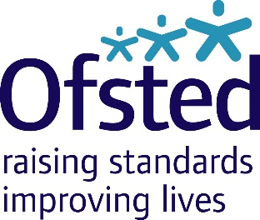
28 June 2017

Sean Flood
Headteacher
Our Lady and St Joseph Catholic Primary
Buckingham Road
London
N1 4DG
Ofsted 2016 ̶ 17 thematic survey programme: the Reception curriculum

Dear Mr Flood

Thank you for your hospitality and cooperation, and that of your staff and children, during my visit on Tuesday 27 June 2017 to look at your approaches to the curriculum in Reception. Thank you also for the documents and other evidence you showed me. This information will be very valuable in informing our report on this important topic.

Ofsted gathers information on the impact of subject and survey visits. To this end, you may be contacted by telephone or sent a questionnaire to complete six to 12 months after the visit.

Yours sincerely

Angela Westington

Her Majesty’s Inspector, Senior

