Arctic Wolf Hunts – KS2 Comprehension
https://www.youtube.com/watch?v=UQKC5pZ0FG8

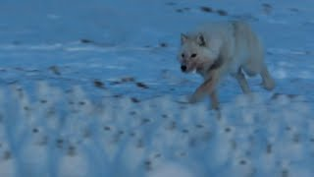
- What adjective is used to describe the wolves at the start of this clip?
- Which animal is revealed to be the focus of unwanted attention from the wolves?
- Pause at 16 seconds. Choose one word to describe the hares at this moment. Explain your answer.
- Why have the Arctic Hares gathered together in large groups?
- Pause at 48 seconds. How do you think the wolf is feeling at this moment? Explain your answer fully.
- Sir David Attenborough says, “Even if they do catch one, its not much of a meal.” What does this mean?
- Sir David Attenborough says, “Sometimes you just have to admit defeat.” What do you understand the phrase ‘admit defeat’ to mean?
- How does the music chosen in this clip affect the mood? Why do you think this choice of music was made?
- How does this clip make you feel sorry for the Arctic Wolf? Explain your answer fully.
- Has this clip made you want to watch the rest of this episode of A Perfect Planet? Why?
- Summarise this clip in a paragraph, then in a single sentence, then with one word.

