Autumn Term
Curriculum Newsletter

Dear Parents and Carers,

A warm welcome to Year One! I hope you had a relaxing and enjoyable summer holiday. I am delighted to be teaching Year One this year. We are covering lots of exciting topics, and I am looking forward to helping each child reach their full potential. Below is an outline of the curriculum for the Autumn Term.

English: Children have daily supported reading and phonic sessions. There will be a big focus on phonics in Year One. We encourage children to blend sounds together to read and then segment words into sounds to help them make phonically plausible attempts at spelling. We will cover fiction, non-fiction and poetry. To help children achieve their objectives we use a range of books and techniques such as role-play. The grammar focus will be to form upper and lower case letters correctly, use capital letters and full stops accurately and write leaving spaces between words. Children must say their sentence out loud before they write it, then read their work back to check it makes sense.

Maths: Throughout the term our targets include to count, read and write numbers to 100. Children will learn to solve addition and subtraction problems by adding and subtracting one-digit and two-digit numbers to 20, including 0. Children will find one more and one less to 100 and learn number bonds to 20. We will begin to build a basic understanding of place value. We will be doubling and halving. We will also be looking at measure and shape, including recognising 2D and 3D shapes.

RE: We will be learning about the Domestic Church (family), Baptism (belonging and a welcome to God’s family) and Advent (loving and Christmas). We will also be a part of Key Stage One’s Nativity play.

ICT: We will be using the Internet to research our topics,
and iPads are used in class to support learning.

Science: We will begin by learning about the topic ‘Animals including Humans’. Children will name human body parts and learn about our senses. We will compare different animals. We will then move on to seasonal changes. Science and Topic are closely linked this term. Lots of artwork is incorporated into lessons.

Topic: We will be learning about British castles, making our own coat of arms and role-playing medieval occupations. We will also look at seasonal changes, learning seasonal weather patterns and creating our own weather station.

Monday | Tuesday | Wednesday | Thursday | Friday
- PE  -Books are changed.  - Homework to be handed in.  -New spellings given. |  | - PE | - Books are changed.  - New homework given out. | - Weekly spelling test. The spellings are often linked to the phonic sounds learnt that week.

There are a lot of changes for the children when moving from Reception to Year One. We aim to make the transition as smooth as possible for the children by maintaining play-based learning in the afternoon for the first half term. My priority is to make sure all the children feel happy and confident moving into Year One!

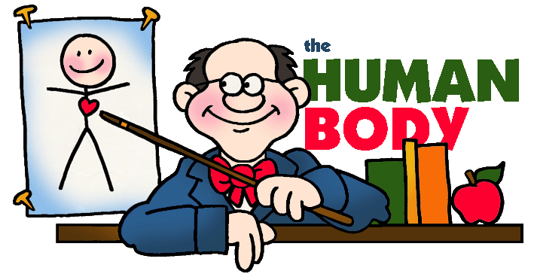
Your continued support at home is invaluable in helping your child progress this year. Please encourage your child to read a variety of books; listening to your child read and reading to them as much as possible would be particularly beneficial. Please don’t hesitate in contacting me if you have any questions regarding the curriculum, phonics or any other matter.

Many thanks
Emma Sharpe (Year One Class Teacher)

