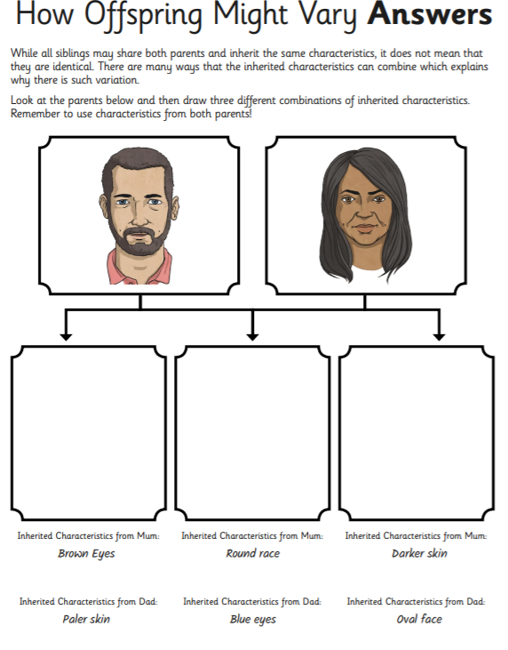
Your answers will vary from these, these are just an example!

