OLI: To learn more about the books of the Bible

The Bible includes poetry, legal documents, songs, letters, eyewitness accounts, biography, historical documents and advice literature. These may be categorised into five different types of books written in different genres.

Historical books: these books give an account of special events in the life of the Jewish people. They are not history as we know today, but a record of God leading his people through episodes and characters e.g. 2 Samuel 2, David is made king of Judah.
Poems and hymns: these could be a prayer as a thanksgiving or in praise of God. They were used at daily services in the Temple and synagogue, and today by Jewish people and Christians in their worship e.g. Psalm 117 Praise the Lord all you nations.
Wise sayings: these are short and easy-to-remember sayings, used by people in their everyday lives e.g. Proverbs 6: 6-11 Learn from the ant.
Good News: the Gospels. They are not a biography of Jesus, but record the memories about Jesus and of those whose lives were changed through contact with him e.g. Matthew
18: 1-5. Jesus welcomes children.
Letters: (we’ll be look at these more later in the topic)

Looking up Biblical text takes a little practice. Like using a dictionary, it helps to know where to begin to look. When you want to read a particular text in the Bible, you would use a reference for example 1 Kings 10: 23-25.

1 Kings that is the first book of Kings
10 is the number of the chapter in that book
23-25 refers to the verses in that chapter. These are the small numbers used to divide up the chapter.

Task
Look up the following references in the Bible:
- Isaiah 44: 2
- Luke 22: 54-57
- Psalm 5: 1-3,
- Matthew 21: 1-5
- Psalm 150: 1-6

Make a note of which book of the Bible it comes from. Look back at the five books of the Bible above- is it in the Historical books, Poems & Hymns, Wise Sayings, Good News or Letters? Make a note of what the Bible reference is about. You can complete this information in the table uploaded on the other document or make your own notes on paper.

If you do not have access to a Bible at home you can use this website: https://www.biblegateway.com/

Type the reference here and click here to change to the Good News Translation

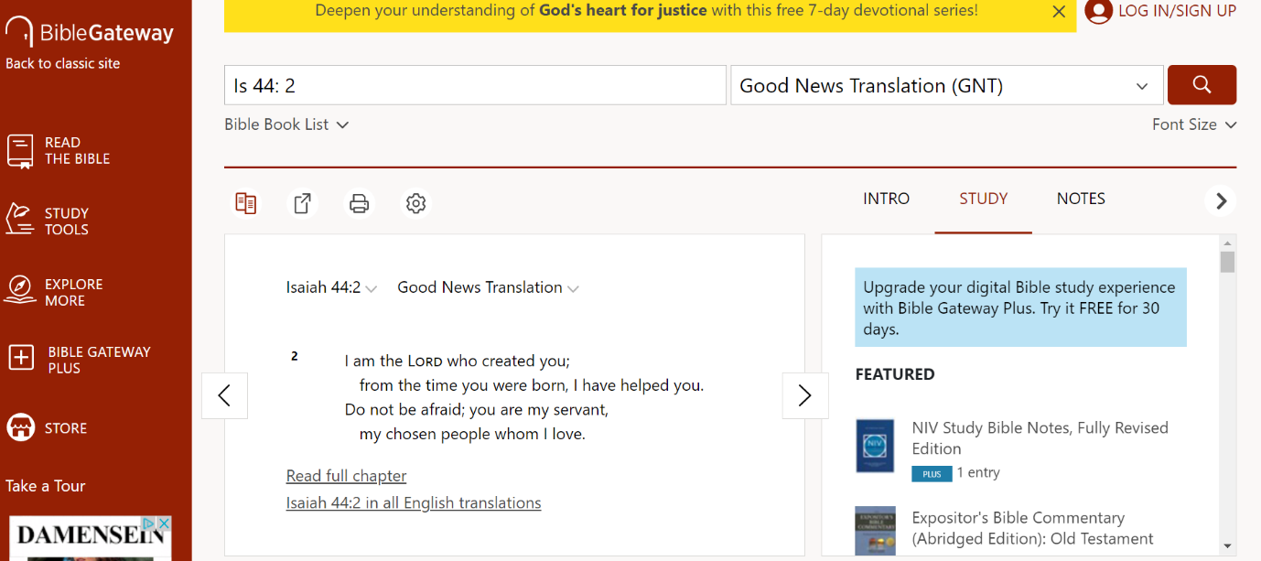

The reference should then appear here

